**TRAFFIC MANAGEMENT SYSTEM USING IOT**

**SHIBINA S S**

**1. Introduction**

* Traffic congestion on road networks creates many problems such as increased fuel consumption, increase air pollution, increased queuing of the vehicles and many more.
* When the number of vehicles exceeds on the road and the traffic controller is not very effective then the traffic congestion occurs.
* In every cities of India traffic congestion is a major problem which we are facing nowadays.
* Traffic congestion is caused when the number of vehicle exceeds the available road capacity and second if the proper management is not available. This is known as saturation
* [1]. Individual incidents such as accidents or sudden braking of a car in a smooth flow of heavy traffic have the highest effects of the slowing speed and cause traffic jams • [2]. There are also even a severe many security problems in traffic system in our country due to many elements which also leads to the congestion of traffic at one place.
* In India, there is an annual loss of Rs 65,000 cores due to traffic congestion which also includes fuel wastage. Congestion in India has also led to slow speeds of freight vehicles, increases fuel consumption, increase air pollution and increased waiting time at checkpoints and toll plazas
* [3].As per data the average speed of vehicles on key corridors like Mumbai-Chennai, Delhi-Chennai is less than 30kmph, while there is 22 kmph on Delhi-Mumbai stretch. As per the road corporation of India , India’s freight volume is increasing annually at a rate of 9.08% and that of vehicles at 10.76%, but that of road is only by 4.01%.
* These all things combined resulted in reduced road space in comparing to the number of total vehicles in the country.
* [3].The average fuel mileage in India is only about 4 km per litre. The major reason for this is traffic congestion
* [3].India is the 2nd most populated country after China in the world, thus with increase in population, the number of vehicles also increasing day by day.
* [4].The economic growth has certainly had an impact on country traffic. As technology is improving or we can say its advancing day by day, more and more people starting to buy cars rather than two wheelers
* [5]. Thus which will directly lead to traffic conjuctions.Hence there is a need to manage traffic in a smart way as the management of traffic with the conventional way such as the smart automatic signalling system to reduce the congestion of the traffic.

# 1.1: IOT (Internet of Things)

It refers to a system consisting of inter related internet connected object that are able to collect and transfer data over a wireless network[6]. In this proposed system, it consists of ARDUINO, IR sensor, Wi-Fi modules.

IR sensors will capture the density of each one so the traffic light time will be assigned on the basis of data collected through it.

# 2. SYSTEM DESIGN AND ARCHITECHTURE

## 2.1: ARDUINO NANO

An 8 bit Microchip AVR which is small, complete and bread board friendly board based on the Atmega328. It is the main CPU of our Project, in which we all the program will run.

**2.2 : POWER SUPPLY MODULE**

A power supply is a hardware component that provides power to any electrical device.

## 2.3 : IR SENSOR

These sensors are used to detect the object through infrared rays. The rays which are thrown from the sensors are reflected back by the object by which it encountered and then after captured by these infrared sensors which further gets converted into electric signals. These sensors are put sideways for giving us the density of vehicles in the specific lane. Infrared sensors are used for signal control, detection of pedestrians in crosswalks and transmission of traffic information [8]. The basic disadvantages of infrared sensors are that the operation of the system may be affected due to fog; also installation and maintenance of the system is tedious [5,9].

**2.4 : WIFI MODULE**

It is used to give microcontroller access to your wife network.

**2.5 : RFRX MODULE**

It consists of RF transmitter and RF receiver; it is used for transmitting and receiving data.

**2.6 : LED**

Light bulbs are used for output and instruction for this system.

## 2.7 : BLYNK APP

It is a mobile application for output and verification for real time data collected.

**2.8 : BLOCK DIAGRAM**

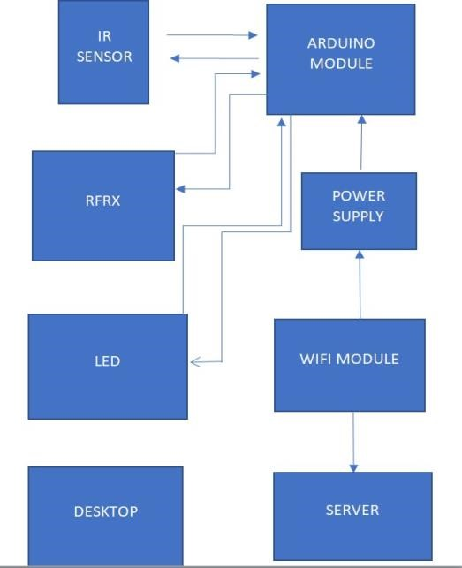

# 3: WORKING PRINCIPLE

There will 8 sensors across the 4 lanes with each lane having 2 sensors each, to give the data how much dense the lane is. If in case the entire lanes have less traffic then the system will work normally means the lanes sequence will be first A lane then B lane, then C lane and at last D lane. But in case if any of the lane gets more cars or gets denser then the other 3 lanes then that specific lane will open then the other with the second highest denser, then the same order continued to the other 2 lanes. If in case all the lanes have same number of vehicles then all the lanes will open in same order i.e. A, B, C, D. If in case there is an emergency vehicle that can be ambulance, fire brigade or an emergency scout team then we have a separate Wi-Fi module through which we can open can lane in which the emergency vehicle is arrived.

# 3.1 : Circuit Diagram

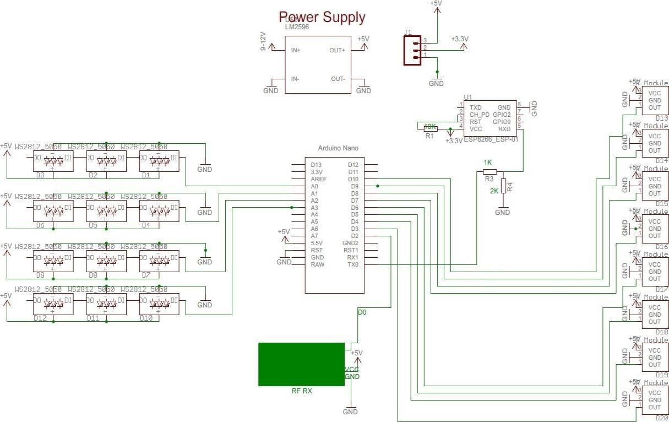

# 3.2 : Existing System

The existing System is generally controlled by traffic police. The main drawback of our system which is controlled by traffic police is that the system is not smart enough to deal with the traffic congestion. The traffic police official can either block a road for more amount of time or let the vehicle on the other road pass by i.e. the decision making may not be smart enough and it entirely depends on the official’s decision.

# 3.2 : Disadvantages of Existing System

* Traffic Congestion
* No means to detect traffic congestion
* Number of accidents are more
* It cannot be remotely controlled
* It requires more manpower
* It is less economical
* It is not efficient

# 3.3 : Proposed System

* The first and primary element of this system is the wireless sensor nodes consists of sensors. The sensors interact with the physical environment means vehicles presence or absence while the local server sends the sensors data to the central micro controller.
* The micro controller receives the signal sent from the sensors and computes which road or which lane has to be chosen based on the density of traffic or no of car.

# 3.4 : Advantages of Proposed System

* Minimize number of traffic
* Reduce fuel cost and saves time and money.
* Low bugdet.
* Easy implementation.
* Remotely controllable.
* It is more efficient
* Requires less man power**.**

**4: Flow Chart with Algorithm**

# Case1

1. Start
2. Check the vehicle Density
3. Vehicle density++
4. Is vehicle density <Threshold
5. Yes
6. Normal Traffic
7. Give green signal to each Lane in a sequential manner

# Case2

1. Start
2. Check the vehicle Density
3. Vehicle density++
4. Is vehicle density <Threshold
5. No
6. Status =congestion
7. Compare the number of density in each lane
8. Open the lane with highest number of density
9. Remove current Lane from Comparison 10. Then start once again.

|  |  |  |
| --- | --- | --- |
| WIFI MODULE WILL KEEP ALL THE EMBEDED NETWORK COMPONENTS INTERCONNECTED TO EACH OTHER AND TRANSFER THE CONTROL TO SERVER. |  | READ THE REAL TIME DATA COLLECTED FROM THE IR SENSOR AND ASSIGN THE CONTROL AS PER THE INBUILD PROGRAM ASSIGNED TO IT. |

|  |  |  |  |
| --- | --- | --- | --- |
| |  | | --- | | ANALYSE THE DENSITY OF TRAFFIC LANES THROUGH IR SENSOR AND TRANSFER THE DATA TO THE MICROCONTROLLER. | | |  | | --- | | SERVER WILL SHOW THE RESULT AS PER THE INPUT OBTAINED AND TRAFFIC LIGHT WILL WORK  ACCORDING TO THAT. | |

# RESULT:-

The proposed system will give output on the basis of density of the traffic lanes so there will be particular time assigned to the lanes for the passing of vehicles so it will lower down the traffic congestion and also in the case of emergency or any road block issue there will be option for that to continue the traffic in normal way and by using blynk app we can check that the system is working according to input or not.

We can see from the image given about the output are coming for various lanes the density in lane one is 100% so other traffic lights are red and the traffic light of lane one will be green until the traffic is cleared so it will repeated for each lane and n the case of emergency on lane will be assigned and other lane will be blocked to control the case of emergency.

The proposed system helps in better time based monitoring and thus has certain advantages over the existing system like minimizing number of accidents, reducing fuel cost and is remotely controllable etc.

The system will be designed in such a way that it will able to control the traffic congestion as well as track the no of vehicles. And it can also be maintained very easily.

The project is user friendly and can replace the existing project.

(a) (b)

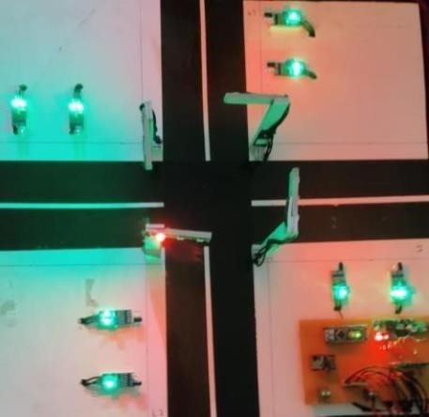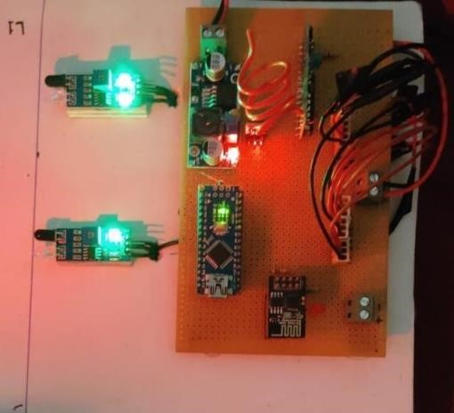

**Screenshot of the Blynk app which is showing live result in mobile phone of the project.**

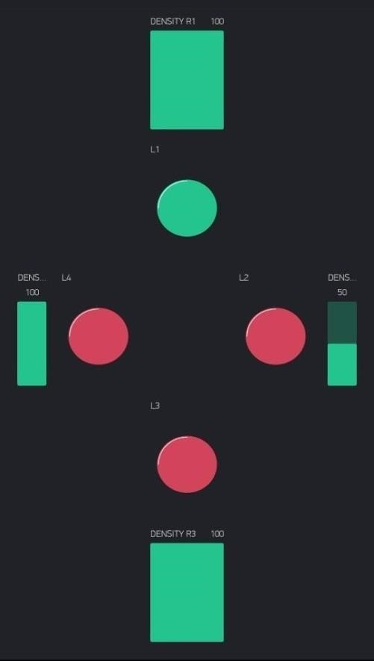 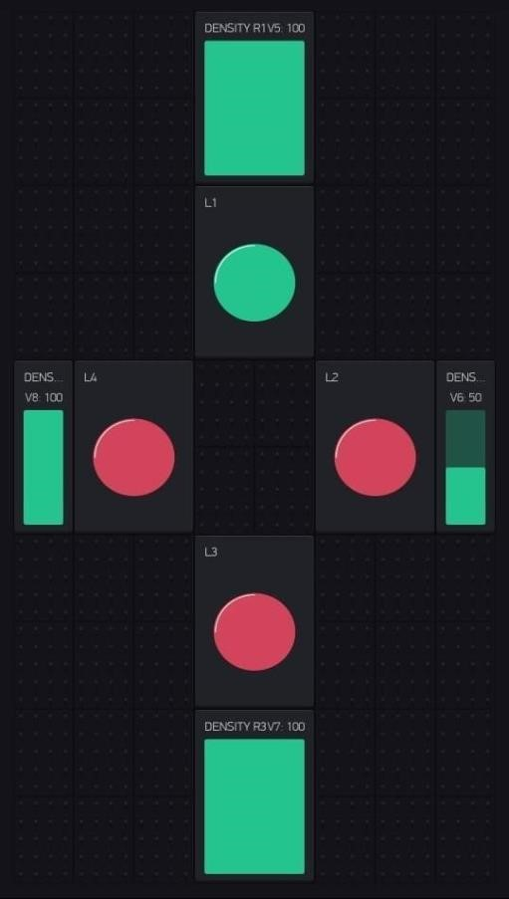

**PROGRAM**

**Python Script**

**import requests**

**import json**

**# Set the traffic data source URL**

**traffic_data_source_url = "https://example.com/api/traffic/real-time"**

**# Set the traffic information platform URL**

**traffic_information_platform_url = "https://example.com/api/traffic/update"**

**# Get the real-time traffic data**

**traffic_data = requests.get(traffic_data_source_url).json()**

**# Prepare the traffic data for sending to the traffic information platform**

**traffic_data_for_platform = {**

**"timestamp": datetime.datetime.now().isoformat(),**

**"traffic_data": traffic_data**

**}**

**# Send the traffic data to the traffic information platform**

**requests.post(traffic_information_platform_url, json=traffic_data_for_platform)**

**Conclusion**

In this research paper we have described about a traffic management system which is working on the basis of Iot and its embedded network and it is taking real time data as the input to track the traffic management system and giving output in terms of time assigned to traffic lights on the basis of density.The existing traffic system has not much option so in future this system can be used to control traffic in smart way by saving time, decreasing the accidents and also it can give real time traffic notification to people so they can choose the right lane or road to pass through. This system is also cost effective than the existing system.

[14]